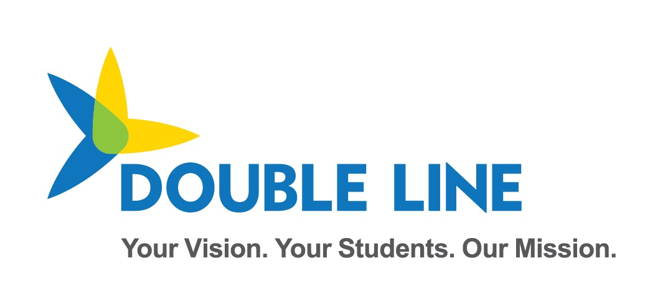

Ed-Fi Updates for School Year 2022-2023

School Year 2022-2023

Minnesota Department of Education & Minnesota IT Services

Automated Student Data Collection System

Revision date: 8/3/2022

Contents

Change Log 3

Data Collection Updates Overview 1

Version Upgrade 1

ESCT has been decommissioned 1

New Resources collected in School Year 2022-2023 1

SchoolAttribute (MN specific extension) 1

StudentNeglectedOrDelinquentProgramAssociation 2

Updated Resources for School Year 2022-2023 3

StudentEducationOrganizationAssociation - Language Academic Honors 3

StudentEducationOrganizationAssociation – Gender Identities 4

StudentEducationOrganizationAssociation – Preferred Pronouns 4

StudentEducationOrganizationAssociation – StudentCrisisEvents 5

StudentLanguageInstructionProgramAssociation 6

StudentSchoolFoodServiceProgramAssociation – Direct Certification 6

Previous MN Extensions which are now part of Ed-Fi Core 7

StudentEducationOrganizationAssociation - Ancestry of Ethnic Origin 7

Early Education - Parent 9

Online Learning Course Completion 9

API Profile Changes 10

Updates to Previously Collected Descriptors 11

KindergartenScheduleDescriptor 11

SchoolFoodServiceProgramServiceDescriptor 11

StudentCharacteristicDescriptor 11

mediumOfInstructionDescriptor 12

# Change Log

|  |  |  |
| --- | --- | --- |
| **Version** | **Date** | **Description of Changes** |
| v1.0 | 04/29/2022 | Initial Version for SY22-23 Collection |
| v1.1 | 05/03/2022 | Minor formatting, typo fix, and note on descriptor tables. |
| v1.2 | 08/03/2022 | Updates reflecting decisions on new collections for school year 2022-23. |

# Data Collection Updates Overview

The following updates or additions will be made in the Minnesota Department of Education’s 2022-2023 Ed-Fi ODS/API.

## Version Upgrade

MDE has upgraded from Ed-Fi ODS/API v3.1.1 to Ed-Fi Technical Suite 3 v 5.2 (Data Standard 3.3.0-a). Documentation on the new version can be found on the Ed-Fi Tech Docs website:

ODS / API v5.2 - <https://techdocs.ed-fi.org/display/ODSAPIS3V520>

Data Standard v 3.3.0-a - <https://techdocs.ed-fi.org/display/EFDS33/What%27s+New+-+v3.3-a>

## ESCT has been decommissioned

Keys and Secrets will now be managed internally at the department of Education. District staff will no longer be required to set up credentials using ESCT. This process will be managed by internal staff using the new Ed-Fi Admin App that comes packaged with Suite 3 v 5.2.

## Updates Planned for school year 2022-23

### StudentSchoolFoodServiceProgramAssociation – Direct Certification

The **DirectCertification** Element has been enabled for collection on the **StudentSchoolFoodServiceProgramAssociation**.

Additionally, “Applied but did not qualify” will no longer be reported as a SchoolFoodServiceProgramServiceDescriptor, and will instead be reported through the with the new **StudentEducationOrganization Association.StudentCharacteristicDescriptor** value “Applied for NSLP but did not qualify”. This change removes the need to create a Program Association record when the student did not qualify for and is therefore, not participating in the program.

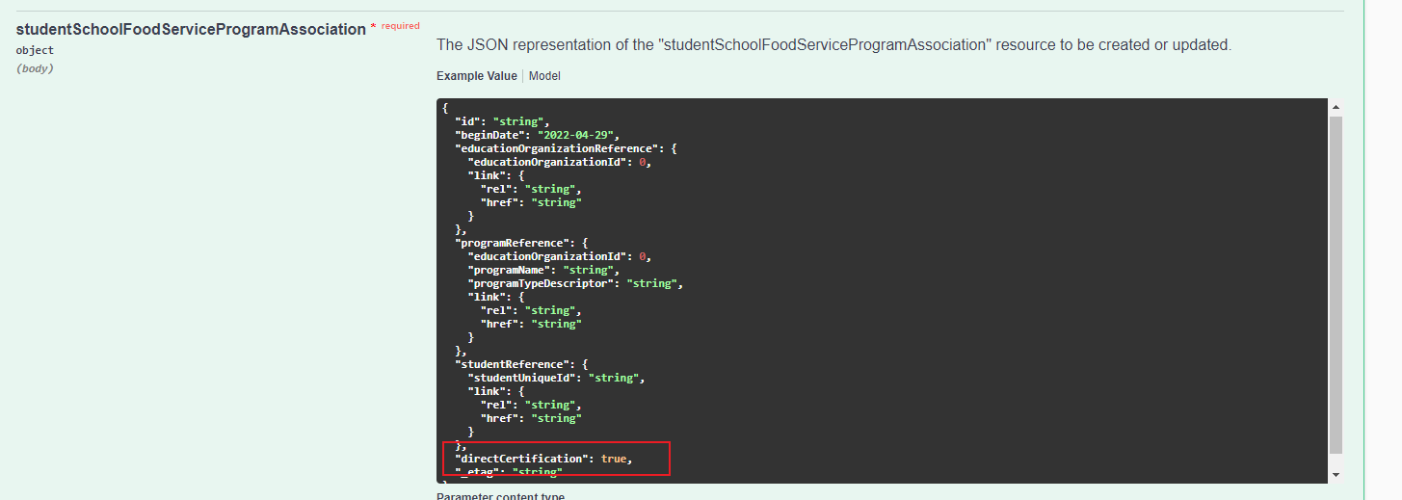

## Previous MN Extensions which are now part of Ed-Fi Core as part of the v.5.2 upgrade

### StudentEducationOrganizationAssociation - Ancestry of Ethnic Origin

***AncestryEthnicOrigin*** *on the StudentEducationOrganizationAssociation entity has changed from a MN extension to a core Ed-Fi data element in Ed-Fi v5.2.*

*The ancestryEthnicOrigins collection has been removed from the MN extension, and is now part of the core resource.*

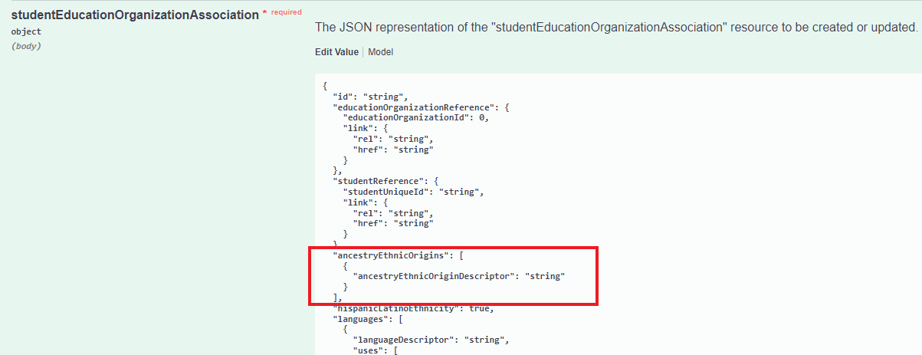

### Early Education - Parent

**HighestCompletedLevelOfEducation** on the Parent entity has changed from a MN extension to a core Ed-Fi data element in Ed-Fi v5.2.

The highestCompletedLevelofEducationDescriptor has been removed from the MN extension, and is now part of the core resource.

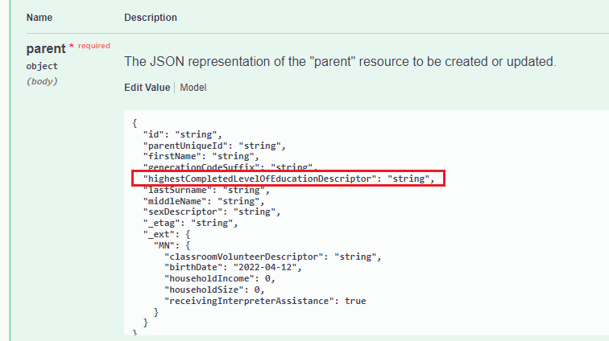

## New Resources Planned (Postponed until after school year 2022-23)

### SchoolAttribute (MN specific extension)

A new resource has been created for the purpose of collecting school specific information. Ed-fi School records are currently created and maintained by MDE, which necessitated a new extension entity to capture school specific data to be provided by the districts for their respective schools.

The schoolAttribute entity will collect the following new elements

* Virtual School Status is collected using **EducationOrganizationIndicator** (Virtual School Status is required for federal EdFacts reporting.)
  + Includes **IndicatorDescriptor** and **IndicatorLevelDescriptor**
* **Title1PartASchoolDesignationDescriptor**

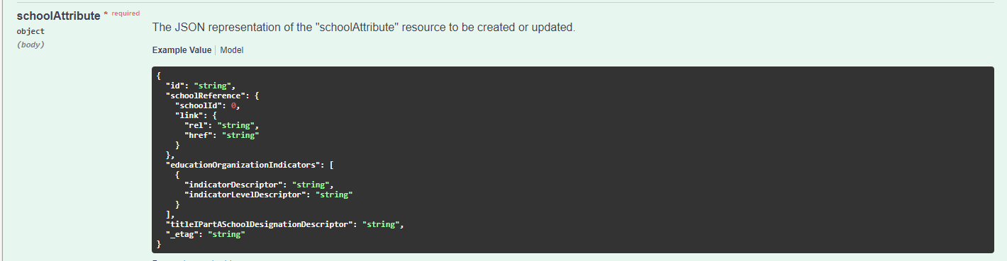

### StudentNeglectedOrDelinquentProgramAssociation

This Ed-Fi Core entity will now be collected by MDE for federal Title I Part D reporting.

MN extension elements neglectedOrDelinquentProgramOutcomeDescriptor and exitedNeglectedOrDelinquentProgramOutcomeDescriptor have been added to record program outcomes. Both extensions use values from the same descriptor list – neglectedOrDelinquentProgramOutcomeDescriptor.

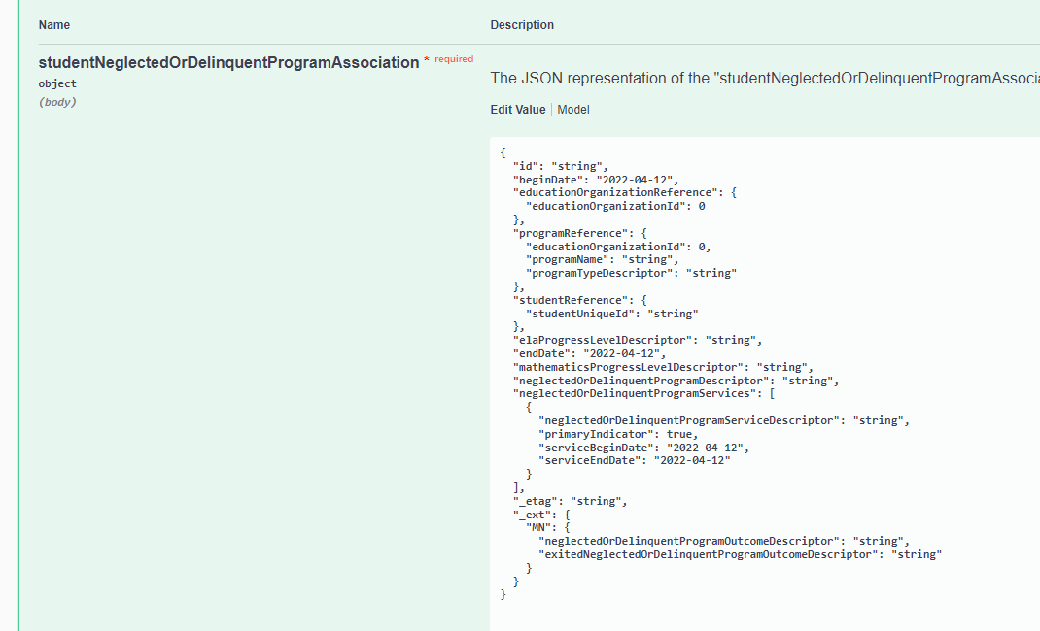

## Updated Resources Planned (Postponed until after school year 2022-23)

### StudentEducationOrganizationAssociation - Language Academic Honors

*A Language Academic Honors extension has been added to StudentEducationOrganizationAssociation. This collection object records one or more Student Academic distinctions awarded for languages including World Languages Proficiency Certificate, Bilingual Seal, and Multilingual Seal.*

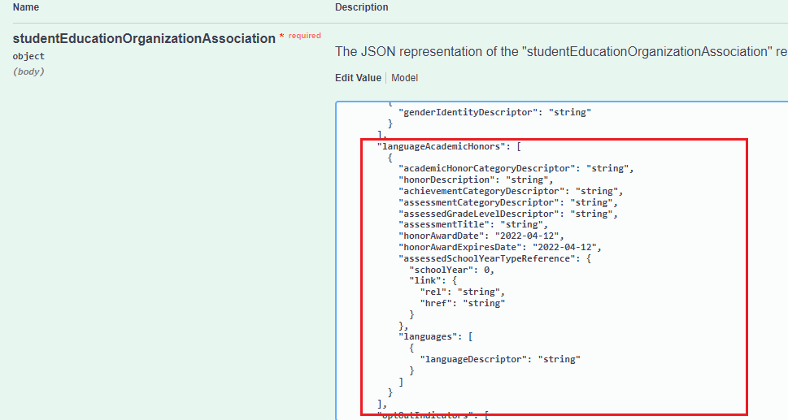

### StudentEducationOrganizationAssociation – Gender Identities

*A Gender Identities extension has been added to StudentEducationOrganizationAssociation. Records a Student’s gender identity. (may be different from SEOA.Sex & Student.BirthSex, which collect the student’s gender reported to the federal government).*

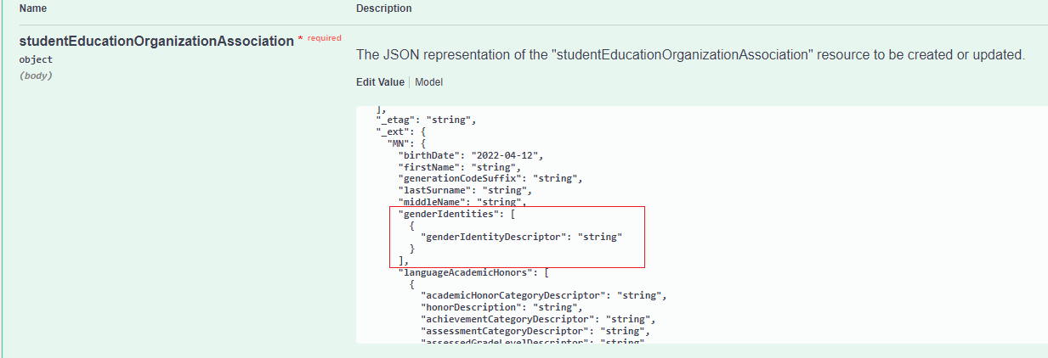

### StudentEducationOrganizationAssociation – Preferred Pronouns

*A Preferred Pronouns extension has been added to StudentEducationOrganizationAssociation. This extension records a Student’s personal preferred pronouns.*

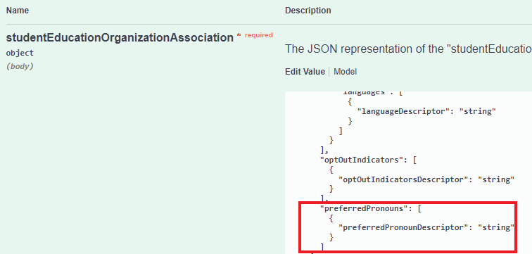

### StudentEducationOrganizationAssociation – StudentCrisisEvents

*A* ***StudentCrisisEvents*** *extension has been added to StudentEducationOrganizationAssociation. This includes* ***crisisEventDescriptor*** *and* ***studentDisplacedIndicator****.*

*For tracking of one or more crisis events causing the student to be temporarily or permanently enrolled in a different school or district.*

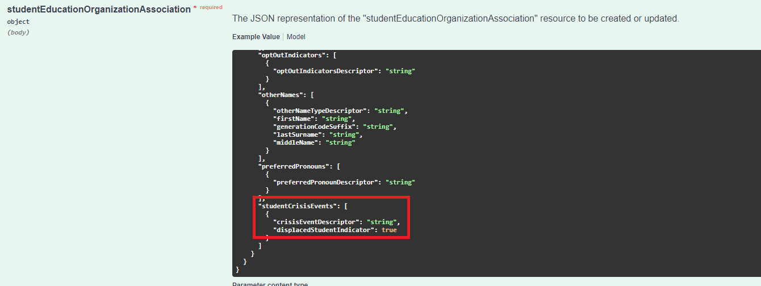

### StudentLanguageInstructionProgramAssociation

* Extension **LanguageInstructionProgramServiceOtherDescription** has been added to the studentLanguageInstructionProgramAssociation to record a description which is conditionally required when LanguageInstructionProgramService = “Other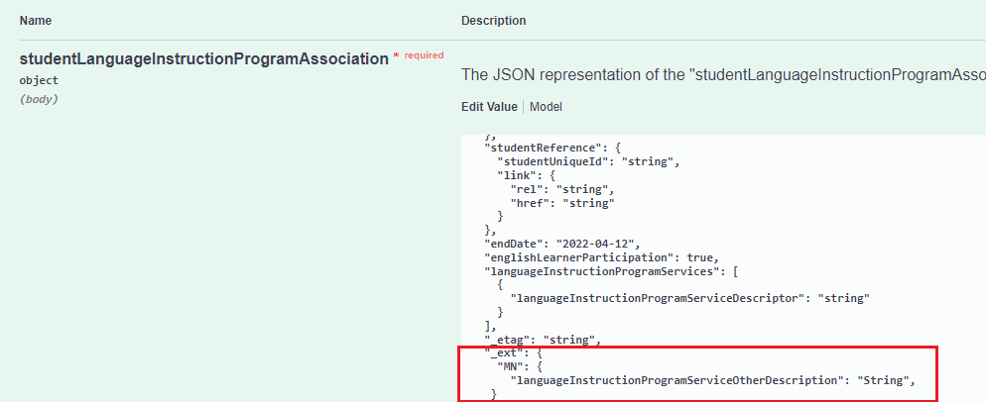”

## Online Learning Course Completion (Postponed until after school year 2022-23)

The OLL/Course Completion file is submitted by state-approved OLL programs to request OLL aid for public school students who complete OLL supplemental courses but who are enrolled in another Minnesota school district.

Currently LEAs submit a fixed field file with Online Learning Course Completion data to MDE.

This fixed field file is loaded into the On Line Learning (OLL) MSFS application and is validated against MARSS-reported student data in MSFS.

The Minnesota Common Course Catalog (MCCC) system data collection includes all of the required data elements for the Online Learning Course Completion (OLL/CC) file except for the STAR Assignment Code (which is no longer a required data element). MDE will use data submitted by the district for MCCC to generate the district’s Online Learning Course Completion file to load into MSFS.

In 2021-2022 and 2022-2023, MDE is piloting MCCC data collection using MDE’s Ed-Fi System, with plans to roll out MCCC data collection using Ed-Fi to all districts starting in 2023-2024. MDE will also pilot using MCCC data to generate the district’s Online Learning Course Completion file in 2022-2024.

The data supporting the generation of the Online Learning Course Completion file will be collected into the following Ed-Fi Entities:

* Student
* StudentEducationOrganizationAssociation
* StudentSchoolAssociation
* Course
* CourseCourseAssociation
* CourseOffering
* Session
* Section
* StudentSectionAssociation
* GradingPeriod
* Grade

Please see the 2022-2023 Data Mapping Matrix for specific fields that have been mapped for Online Learning Course Completion.

## Updates to Previously Collected Descriptors

The following documentation is provided to easily identity changes to descriptor sets which have previously been in use at MDE. For more comprehensive documentation on the 2022-2023 descriptors, please refer to the 2022-2023 Mapping documentation and watch the [descriptorTables folder in GitHub](https://github.com/mn-mde-edfi/MDE-EdFi-Documentation/tree/master/2022-23%20MDE%20Ed-Fi%20Documentation/descriptorTables) for changes.

### KindergartenScheduleDescriptor

|  |  |  |  |
| --- | --- | --- | --- |
| **Add/Remove/Update** | **CodeValue** | **ShortDescription** | **Description** |
| Remove | P-Do Not Use | P - Half-day, two days a week - Preschool Only | P - Half-day, two days a week - Preschool Only |
| Remove | Q-Do Not Use | Q - Half-day, three days a week - Preschool Only | Q - Half-day, three days a week - Preschool Only |
| Remove | R-Do Not Use | R - Half-day, four days a week - Preschool Only | R - Half-day, four days a week - Preschool Only |

### SchoolFoodServiceProgramServiceDescriptor

|  |  |  |  |
| --- | --- | --- | --- |
| **Add/Remove/Update** | **CodeValue** | **ShortDescription** | **Description** |
| Remove | 7 | Applied but did not qualify | Applied but did not qualify |

### StudentCharacteristicDescriptor

|  |  |  |  |
| --- | --- | --- | --- |
| **Add/Remove/Update** | **CodeValue** | **ShortDescription** | **Description** |
| Add | 10 | Applied for NSLP but did not qualify | Applied for National School Lunch Program but did not qualify |
| Remove | 7 | Displaced by Hurricanes, Tropical Storms, or Flooding in 20-21 | Displaced by Hurricanes, Tropical Storms, or Flooding in 20-21 |
| Remove | 8 | Displaced by Wildfires in 20-21 | Displaced by Wildfires in 20-21 |
| Remove | 9 | Displaced by Afghan Evacuation US Operation Allies Welcome | Displaced by Afghan Evacuation US Operation Allies Welcome |

### mediumOfInstructionDescriptor

|  |  |  |  |
| --- | --- | --- | --- |
| **Add/Remove/Update** | **CodeValue** | **ShortDescription** | **Description** |
| Add | DFSL | District-Funded Supplemental | Use this designation for district-funded online courses that can be taken to replace courses offered in the enrolling district. |
| Add | SFSL | State-Funded Supplemental | Use this designation for state-funded online courses that can be taken to replace courses offered in the enrolling district. One specific use is by state-approved online providers to indicate supplemental online courses. |
| Remove | SL | Supplemental | Use this designation for online courses that can be taken to replace courses offered in the enrolling district. One specific use is by state-approved online providers to indicate supplemental online courses. |

## API Profile Changes

***Note: Decisions reflected in this section are currently under review.***

A new profile “Minnesota-Twenty-Two-Twenty-Three-Baseline-SIS-Vendor-Profile” has been created which allows submission of data against data entities and elements collected and certified in prior school years.

Every LEA that had been granted a key and secret with access to submit data for the 2021-2022 school year, will receive a key and secret associated with this new profile leading up to the start of the 2022-2023 school year.

Once vendors certify against the new 2022-2023 certification requirements, a new key and secret will be issued and associated with the “Minnesota-Twenty-Two-Twenty-Three-SIS-Vendor-Profile” for all districts using the certified vendor. This profile will include the baseline entities, in addition to anything new for 2023-2023.